Power BI Testing
Functional and performance testing plan for incident dashboards
Project: ServiceNow Incident Lifecycle Automation | Phase: Development - Performance Testing

1. Purpose and Scope
This plan verifies that Power BI reports built on incident data (for example MTTR, SLA compliance, backlog and recurring incidents) show correct numbers and load and refresh within acceptable time.
In scope:
- Data accuracy against the ServiceNow source
- Report load time, visual rendering and slicer response
- Dataset refresh duration and reliability
- Row-level security and access
Out of scope:
- Source data quality fixes in ServiceNow
- Tenant-wide Power BI service performance

2. Test Objectives
- Confirm every key measure matches the source figures.
- Confirm reports open and respond quickly with realistic data volume and users.
- Confirm scheduled refresh completes within its window.
- Confirm users see only the data they are entitled to.

3. Test Scenarios and Targets
Targets below are proposed starting points. Confirm or replace them with agreed service levels before execution.
ID | Scenario | Metric | Proposed target
PB-01 | Reconcile total incidents, open and closed counts with ServiceNow | Data accuracy | Exact match for the same period
PB-02 | Verify MTTR and SLA compliance calculations on a sample | Measure correctness | Matches manual calculation
PB-03 | Open the main dashboard | Load time | 5 seconds or less
PB-04 | Apply filters and slicers | Interaction time | 3 seconds or less
PB-05 | Scheduled dataset refresh | Refresh duration, success | Completes in its window; no failures
PB-06 | Concurrent users open reports | Load time under load | 95th percentile within 8 seconds
PB-07 | Row-level security for different roles | Access control | Each role sees only permitted data

4. Test Approach
- Test with a full-size dataset, then with filters that produce edge cases (no data, one record).
- Use Performance Analyzer to find slow visuals and DAX measures.
- Test each security role with a test account.

5. Tools
Tool / area | Use
Power BI Desktop | Performance Analyzer for visual and query timings
DAX Studio | Inspect measure and query performance
ServiceNow reports | Source of truth for reconciliation
Test accounts | Role-based access checks

6. Test Data and Environment
- Test workspace separate from production.
- Dataset with production-like volume.
- Documented data source credentials and refresh schedule.

7. Entry and Exit Criteria
Type | Criteria
Entry | Report built and data model stable; source data loaded; reconciliation queries ready.
Exit | Data matches the source; load and refresh targets met; security verified; defects closed or accepted.

8. Risks
Risk | Mitigation
Source data changes during testing | Use a fixed extract date for reconciliation
Slow visuals from complex measures | Optimise the model and measures, then retest
Refresh clashes with other jobs | Choose a refresh window and monitor failures

9. Results Log
ID | Scenario | Result | Pass / Fail | Notes

Process Diagram
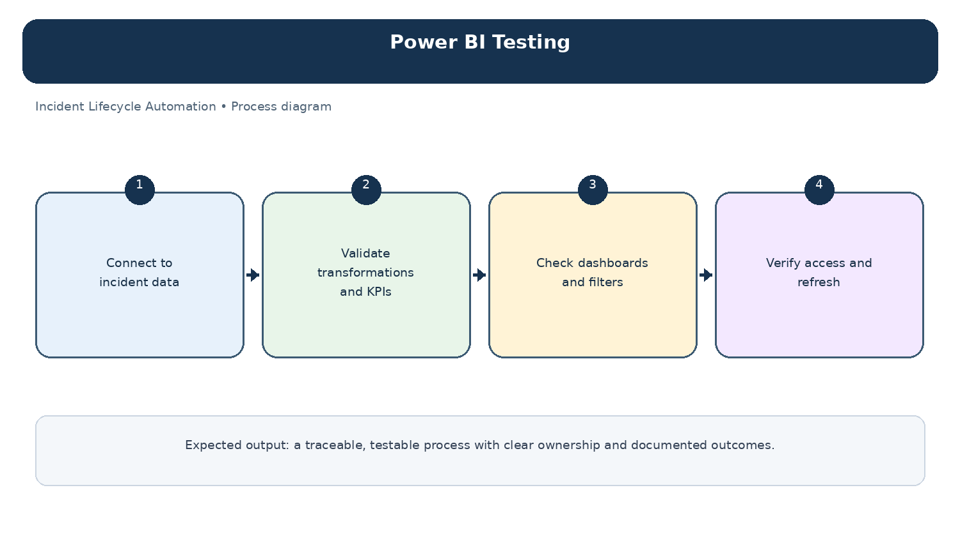
Diagram: Power BI Testing — project-specific process overview.

